Picture Overview


Products

Picture | Caption
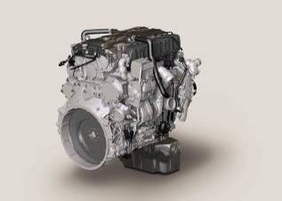  MTU_4R1000C.jpg  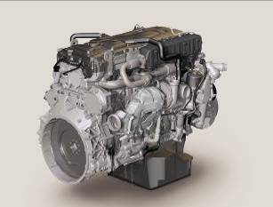  MTU_6R1000C.jpg | Series 1000  From 2014, the Series 1000 diesel engines (4R 1000, 6R 1000) will cover a power range from 100 to 260 kW (135 to 350 bhp). These units have been specially developed for off-highway applications in the construction, industrial and agricultural sectors and are based on Daimler technology. They will utilize an SCR exhaust aftertreatment system to achieve compliance with the extremely stringent limits set by EU Stage IV and EPA Tier 4 final for nitrogen oxides and particulate emissions. However, the units do not need diesel particulate filters and therefore offer significant benefits in terms of installation space and weight.  Pictured: 4R 1000 C, 6R 1000 C
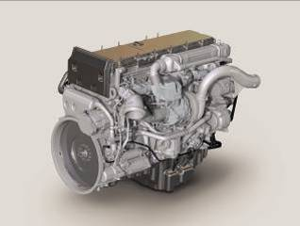  MTU_6R1100C.jpg | Series 1100  From 2014, the Series 1100 six-cylinder in-line diesel engine will cover a power range from 280 to 320 kW (375 to 430 bhp). These units have been specially developed for off-highway applications in the construction, industrial and agricultural sectors and are based on Daimler technology. They will utilize an SCR exhaust aftertreatment system to achieve compliance with the extremely stringent limits set by EU Stage IV and EPA Tier 4 final for nitrogen oxides and particulate emissions. However, the units do not need diesel particulate filters and therefore offer significant benefits in terms of installation space and weight.  Pictured: 6R 1100 C
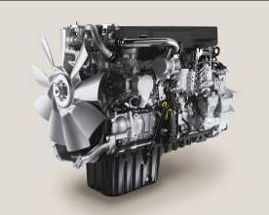  MTU_6R1300C.jpg | Series 1300  From 2014, the Series 1300 six-cylinder in-line diesel engine will cover a power range from 340 to 380 kW (455 to 510 bhp). These units have been specially developed for off-highway applications in the construction, industrial and agricultural sectors and are based on Daimler technology. They will utilize an SCR exhaust aftertreatment system to achieve compliance with the extremely stringent limits set by EU Stage IV and EPA Tier 4 final for nitrogen oxides and particulate emissions. However, the units do not need diesel particulate filters and therefore offer significant benefits in terms of installation space and weight.  Pictured: 6R 1300 C

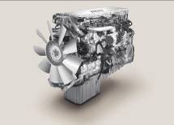  MTU_6R1500C.jpg | Series 1500  From 2014, the Series 1500 six-cylinder in-line diesel engine will cover a power range from 400 to 460 kW (535 to 615 bhp). These units have been specially developed for off-highway applications in the construction, industrial and agricultural sectors and are based on Daimler technology. They will utilize an SCR exhaust aftertreatment system to achieve compliance with the extremely stringent limits set by EU Stage IV and EPA Tier 4 final for nitrogen oxides and particulate emissions. However, the units do not need diesel particulate filters and therefore offer significant benefits in terms of installation space and weight.  Pictured: 6R 1500 C
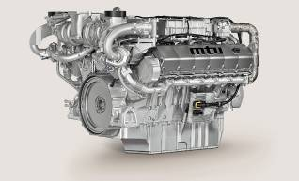  MTU_12V1600C.jpg | Series 1600  The new Series 1600 engines will be available from 2014 for the power range 560 up to 730 kW (760 up to 980 bhp). The Series 1600 agricultural engines need neither SCR systems nor diesel particulate filters to achieve compliance with the US emission stage EPA Tier 4 final.  Pictured: 12V 1600 C

Technologies

Picture | Caption
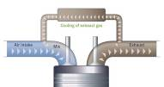  MTU_EGR.jpg | Exhaust Gas Recirculation (EGR)  In exhaust gas recirculation, some of the exhaust gases are returned to the fresh air intake in the part-load range. The resultant mixture of fresh air and exhaust gas has a lower calorific value in terms of the volume and is thus unable to reach the temperature required in the combustion chamber to produce nitrogen oxide (NO_{x}).
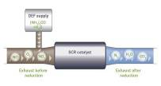  MTU_SCR.jpg | Selective Catalytic Reduction (SCR)  Refers to a method used to minimise nitrogen oxides (NO_{x}) in exhaust emissions. An aqueous urea solution is injected into the exhaust gas upstream of the SCR catalytic converter, resulting in the production of ammonia and carbon dioxide. In the SCR catalytic converter, the ammonia produced in this way reacts with the NO_{x} particulates in the exhaust gas to produce water and nitrogen.

Applications

Picture |  | Caption
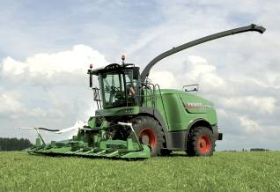  Fendt Katana 65.jpg | Forage Harvester Fendt Katana 65  Tractor manufacturer Fendt has launched its first ever forage harvester, the Katana 65. It is powered by an engine of the MTU Series 500 (based on Mercedes-Benz OM 502 LA) which produces 480 kW (650 bhp). Its SCR system guarantees low fuel consumption combined with high performance. Furthermore, it ensures that the engine meets the EU Stage IIIB and the American EPA Tier 4i emission standards.
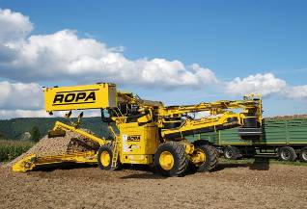  ROPA Euro-Maus 4.jpg | Cleaning Loader ROPA Euro-Maus 4  With the Euro-Maus 4, ROPA has developed a new self-propelled cleaning loader for sugar beet with a more than 10.2 m wide collection system. It is powered by a highly economical engine of the MTU Series 900 (based on Mercedes Benz OM 926 LA) incorporating a SCR catalyst. Thus, the engine meets the emissions standard EU IIIB. It has a power of up to 240 kW (326 bhp).
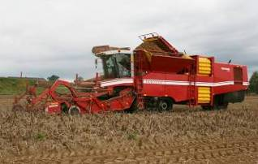  Grimme Tectron 410.jpg | Potato Harvester Grimme Tectron 410  Grimme Tectron 410 is a four-row self-propelled potato harvester with a 10-tonnes large bunker. It is powered by a MTU Series 400 engine (based on Mercedes Benz OM 460 LA) producing up to 360 kW (490 bhp) at 1,650 rpm.
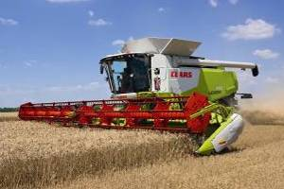  Claas Lexion 770.jpg | Combine Claas Lexion 770  The combine Claas Lexion 770 has cutterbars of up to twelve meters wide and a 12,000 liter grain tank. It is powered by an engine of the MTU Series 500 (based on Mercedes-Benz OM 502 LA), which produces up to 431 kW (586 bhp).
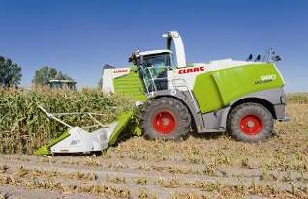  Claas Jaguar 980.jpg | Forage Harvester Claas Jaguar 980  The Claas forage harvester Jaguar 980 is powered by two MTU Series 400 engines (based on Mercedes-Benz (OM 460 LA) which produce together 630 kW (857 bhp) at 1,800 rpm.

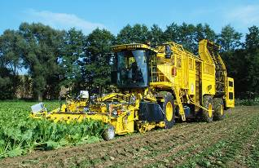  ROPA Euro-Tiger V8-3. jpg | Sugar Beet Harvester ROPA Euro-Tiger V8-3  Euro-Tiger V8-3 from ROPA is a harvester for sugar beet with a capacity of more than 40 cubic meters. It is powered by a MTU Series 500 engine (based on Mercedes-Benz OM 502 LA) producing up to 444 kW (604 bhp).
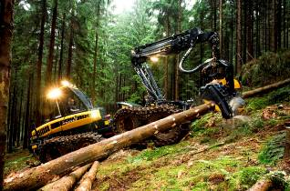  Ponsse Ergo 8W.jpg | Wood Harvester Ponsse Ergo 8W  The eight-wheel wood harvester Ergo 8w of the Finnish manufacturer Ponsse is suitable especially for sloping sites and otherwise demanding terrain. Its engine of the MTU Series 900 (based on Mercedes-Benz OM 906 LA) has a power output of 205 kW (275 bhp).
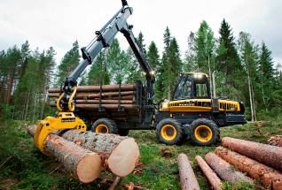  Ponsse Buffalo.jpg | Ponsse Buffalo Forwarder  The Ponsse Buffalo forwarder with its 14-tonne carrying capacity is suitable especially for demanding conditions like sloping sites. It is powered by an MTU Series 900 engine (based on Mercedes-Benz OM 906 LA) which produces a power output up to 205 kW (275 bhp).

